Assignment 6.3 Ai Assisted Coding
Htno:2303a51983
Btno:06
Task 1: Classes (Student Class).
Prompt: Write a Python program to create a Student class.
Requirements:
- The class should have attributes: name, roll_number, and branch.
- Use a constructor (init) to initialize the values.
- Add a method display_details() that prints all student details clearly.
- Create at least one student object and call the method.
- Keep the code simple and beginner-friendly.
Input:
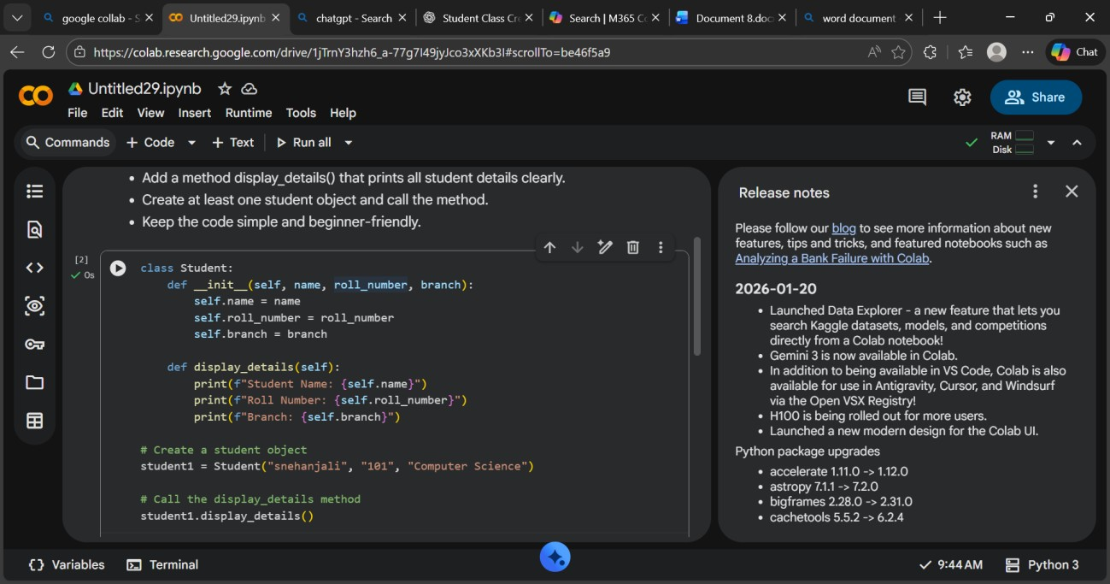
Output:

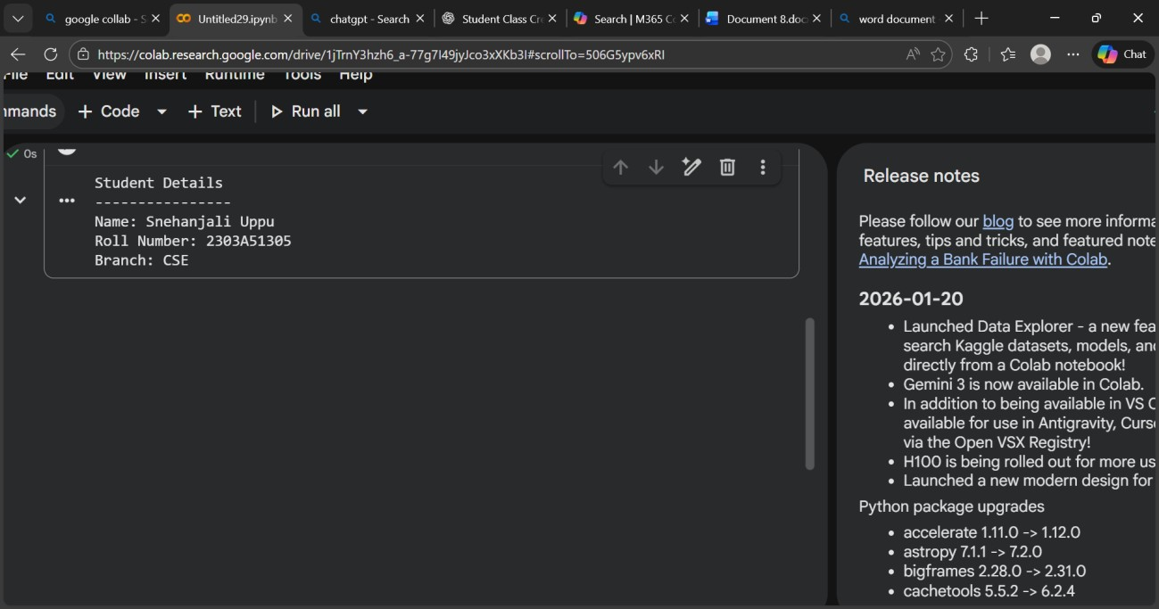
Explanation: The program defines a Student class with attributes (name, roll number, branch) initialized using a constructor.
The display_details() method prints the student information, showing basic OOP concepts like class, object, and methods.

Task 2:Loops of a number.
Prompt: Write a Python function that prints the first 10 multiples of a given number.
Requirements:
- Use a loop structure.
- The number should be passed as a parameter.
- Print the multiples clearly.
- Keep the code simple and beginner-friendly.
Then write another version of the same program using a different loop (while loop instead of for loop).
Input:
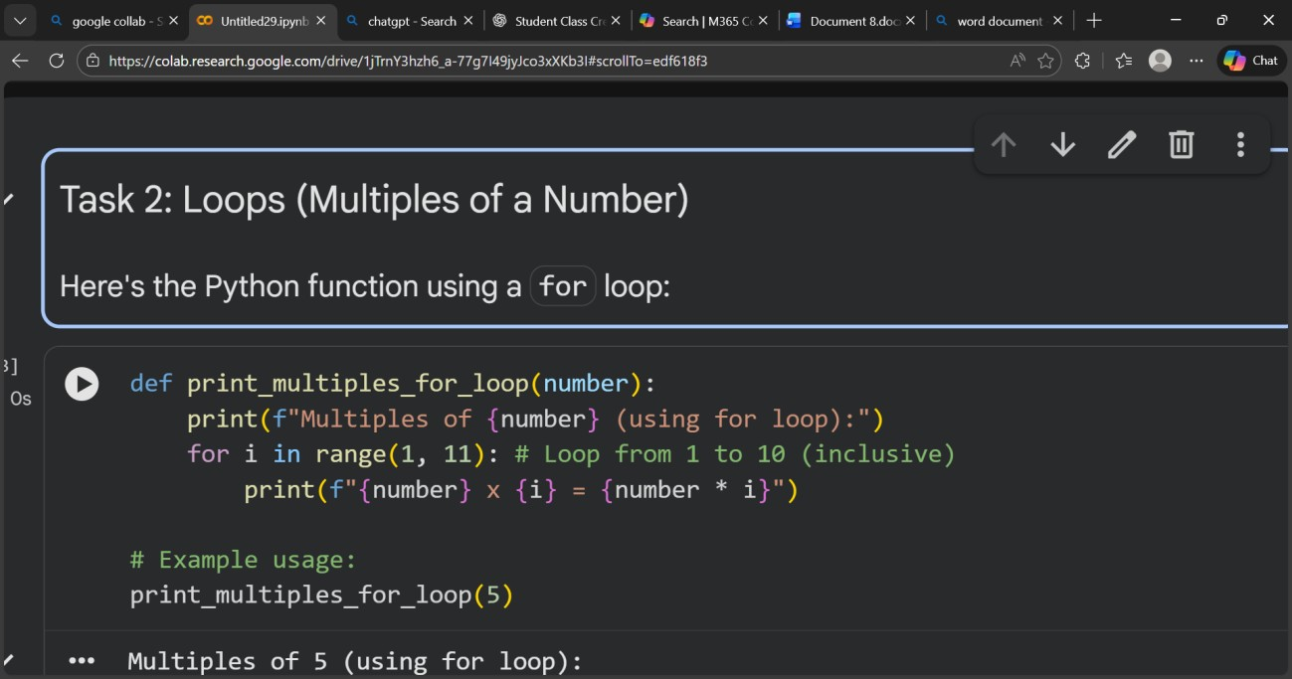
Output:
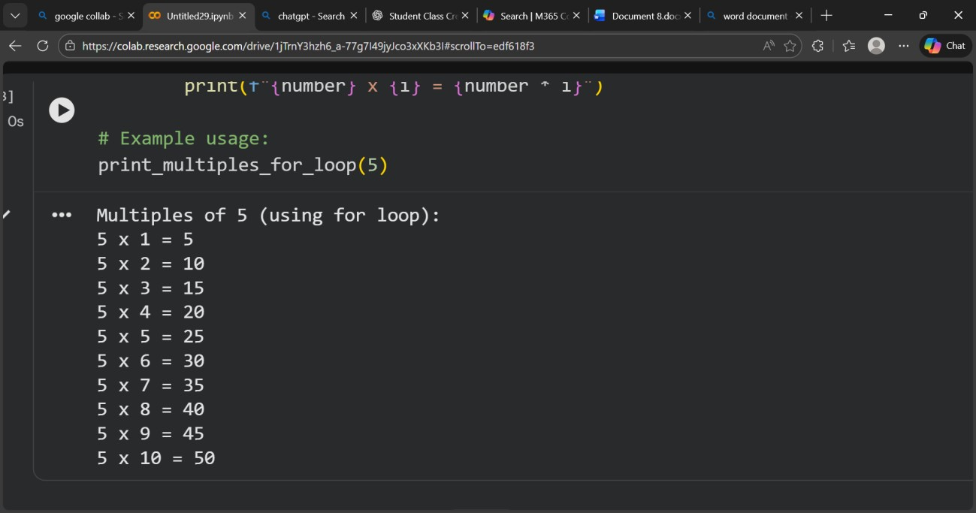
2)Input:
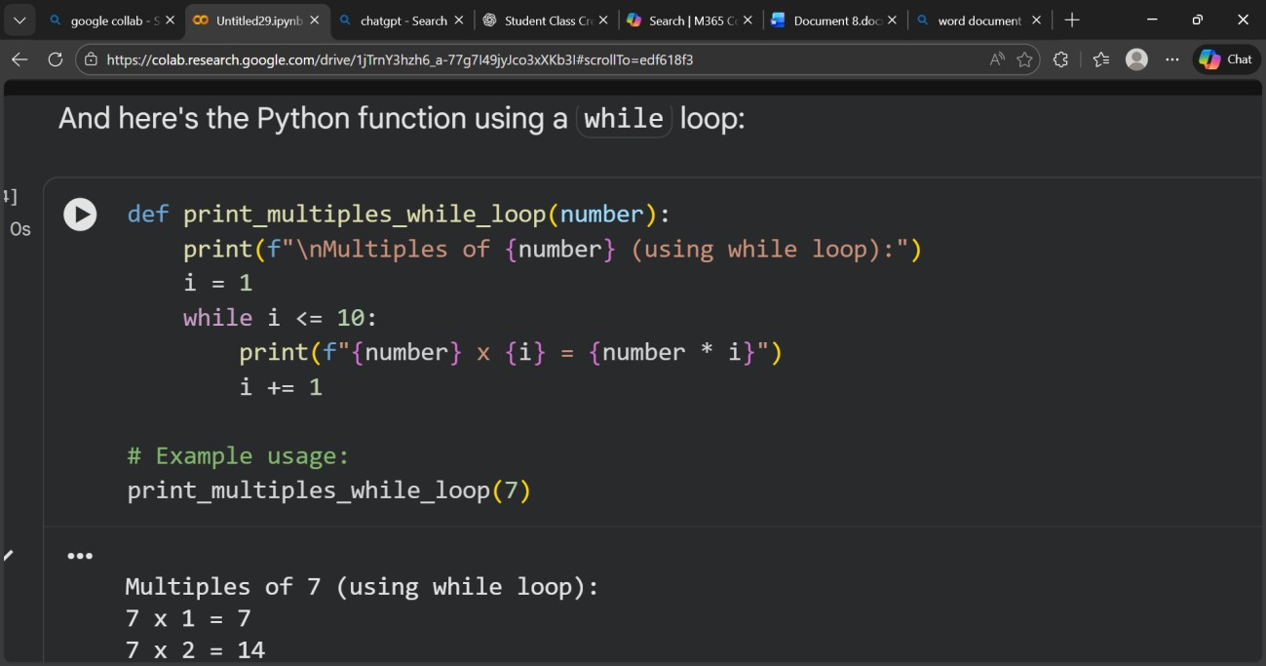
2)Output:
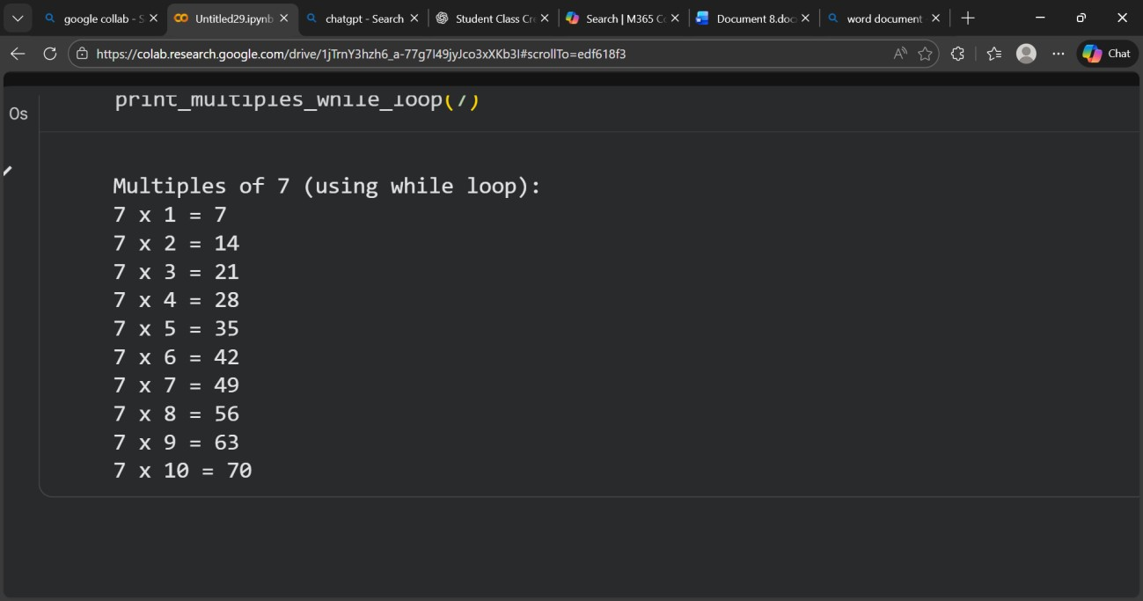
Expalantion: A loop is used to repeat an action 10 times and calculate multiples of a number using multiplication. for loop is best for fixed iterations, while while loop gives more control using a condition.

Task 3: Conditional Statements (Age Classification)
Prompt: Write a Python function to classify a person based on age.
Requirements:
- Use nested if-elif-else statements.
- Age groups:
Child: 0–12
Teenager: 13–19
Adult: 20–59
Senior: 60 and above
The function should take age as input and print the categoryThen generate another version using an alternative approach (simplified conditions or dictionary-based logic).Keep the code beginner-friendly. Input:using if else statements
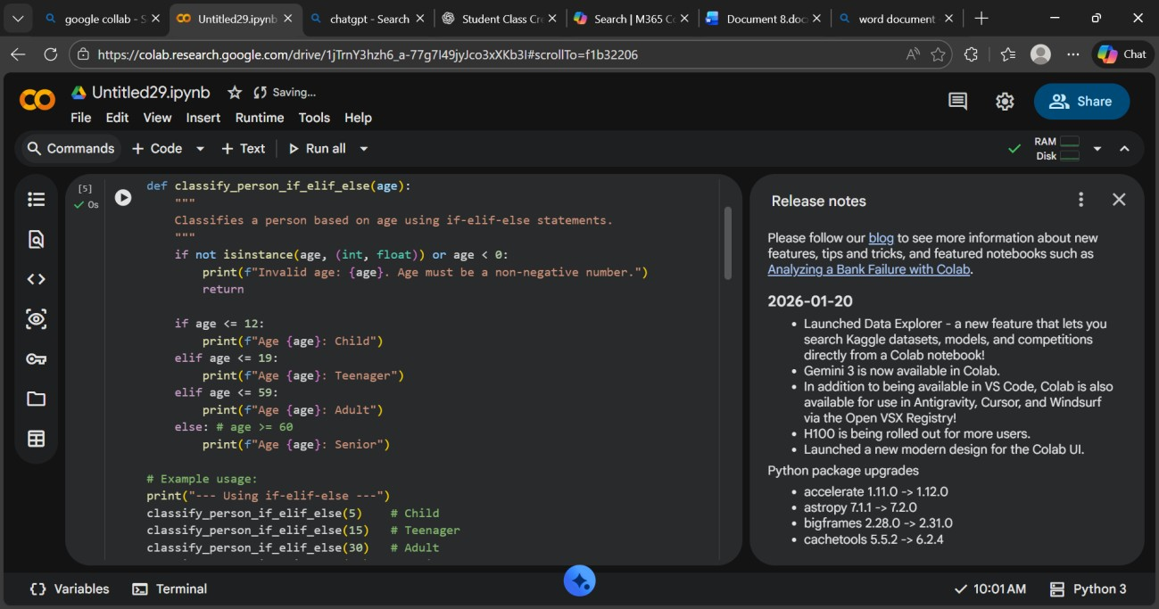
Output:
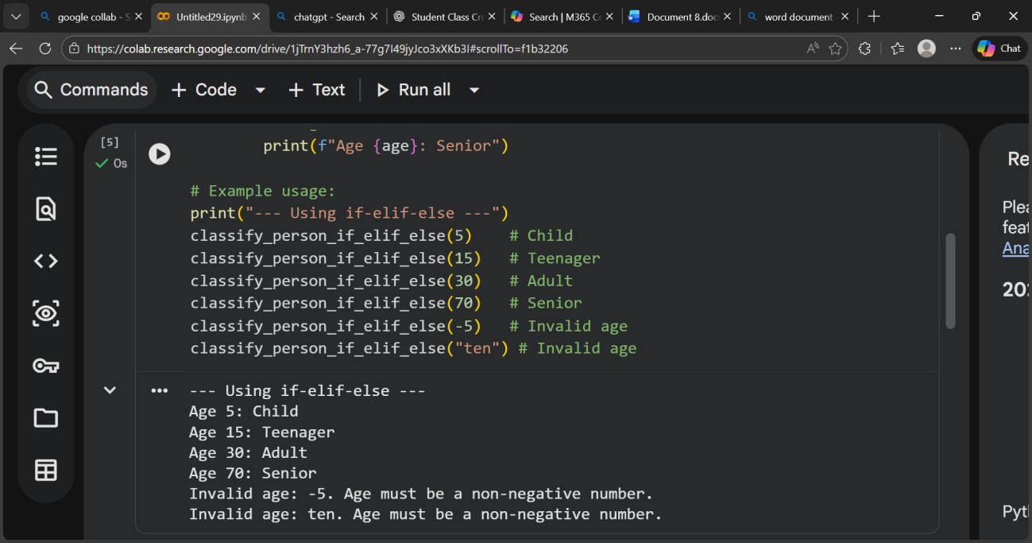
2)input:using alternative methods
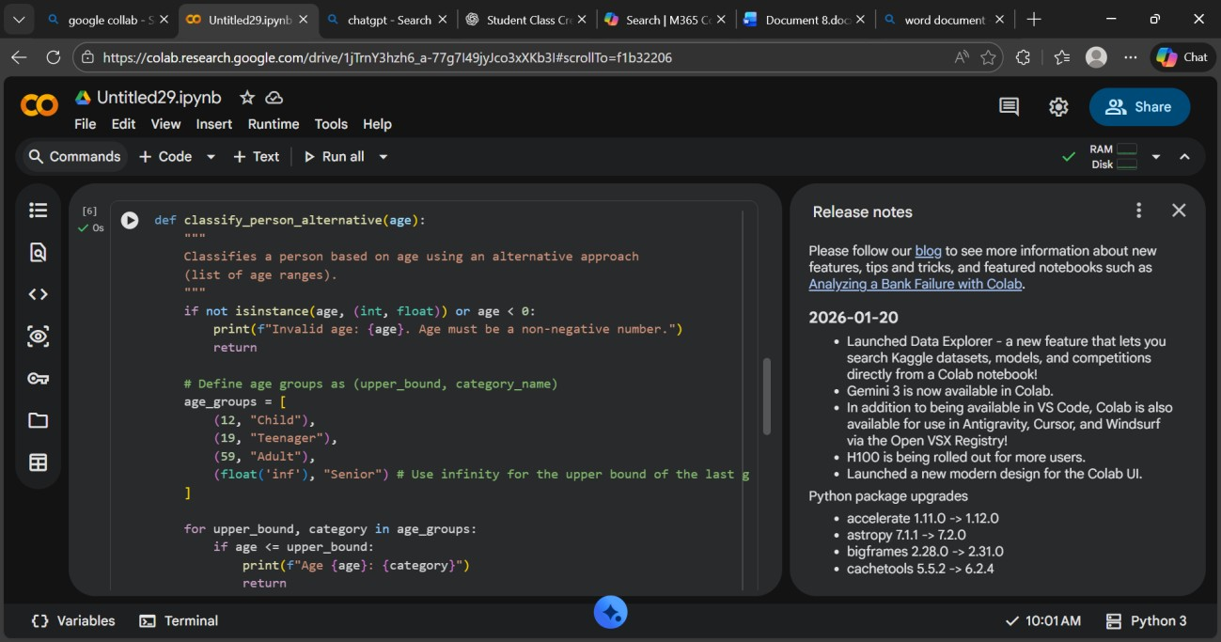
Output:
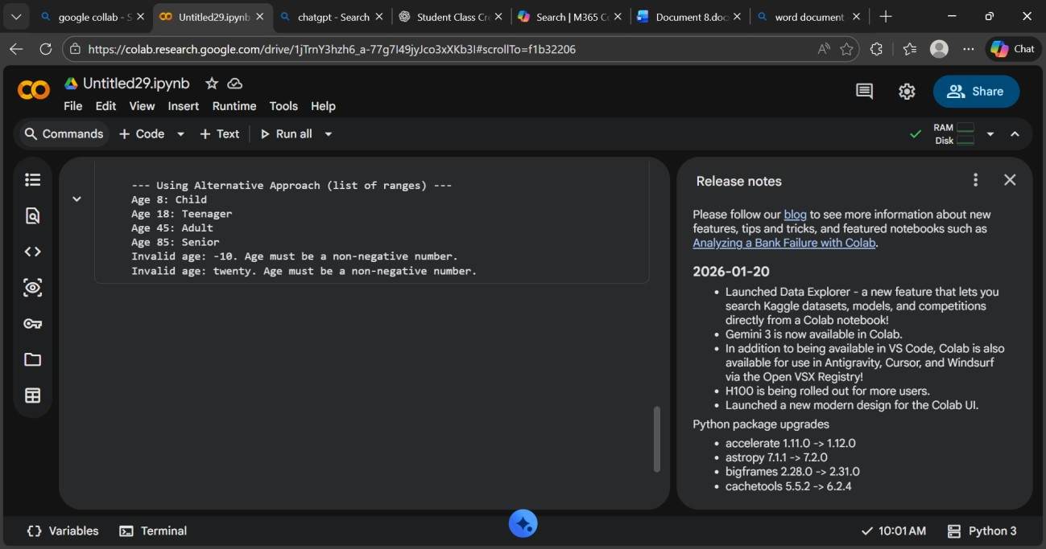
Explanation: Conditional statements (if-elif-else) check age ranges and assign a category like child, teenager, adult, or senior.
The logic works top-to-bottom, and alternative methods like dictionary mapping make the system more flexible.

Task 4: For and While Loops (Sum of First n Numbers)
Prompt: Write a Python function sum_to_n(n) to calculate the sum of the first n natural numbers.
Requirements:
- Use a for loop.
- Keep the code simple.
- Show example function call and output.
Then provide an alternative implementation using:
- a while loop
- a mathematical formula
Explain the differences briefly.
1 Input:
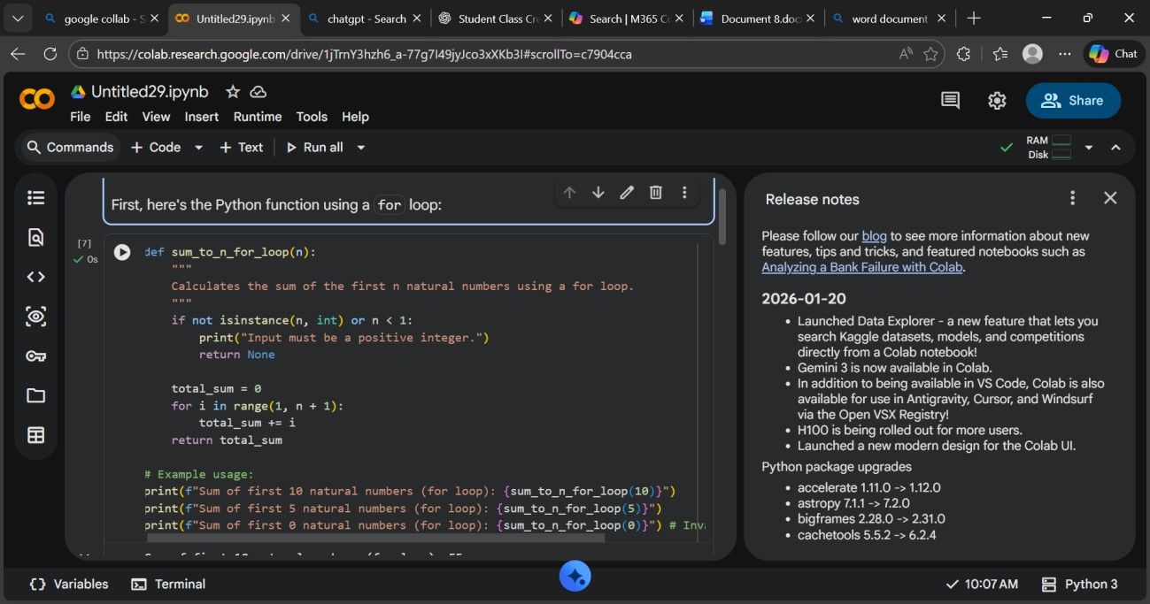
Output:
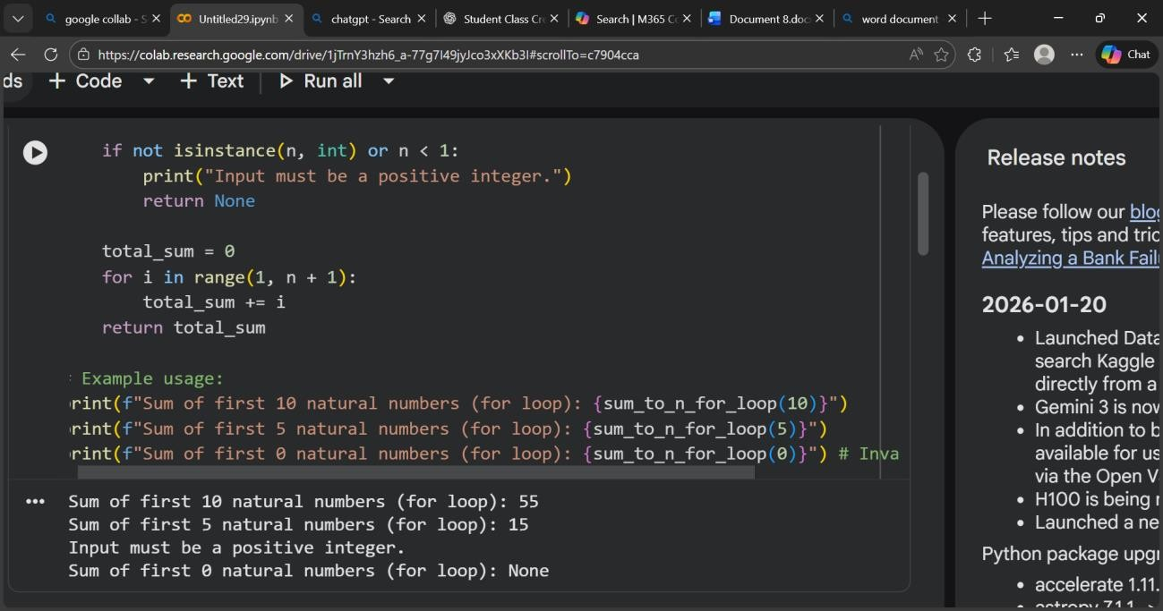
2) input:
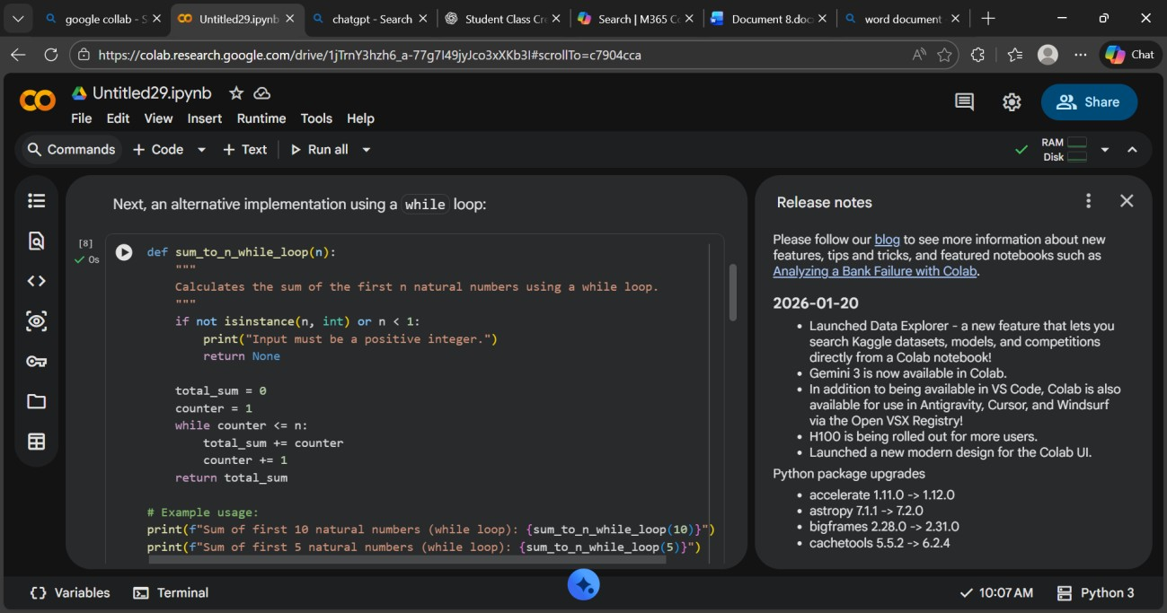
Output:
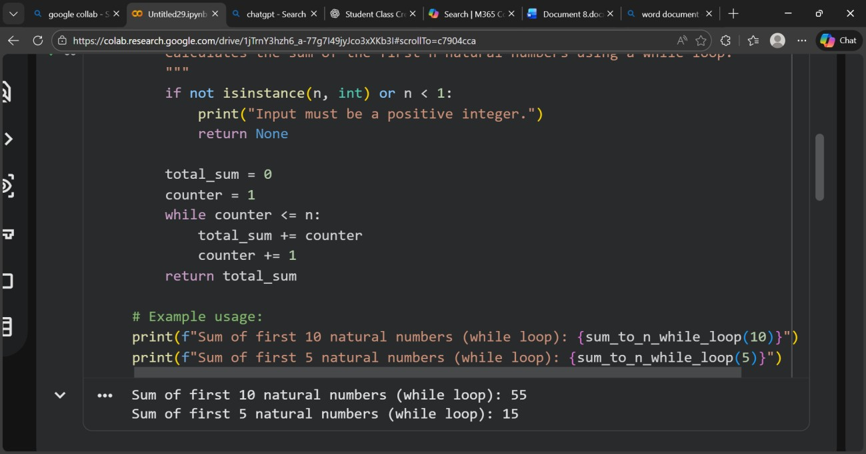
3)input:
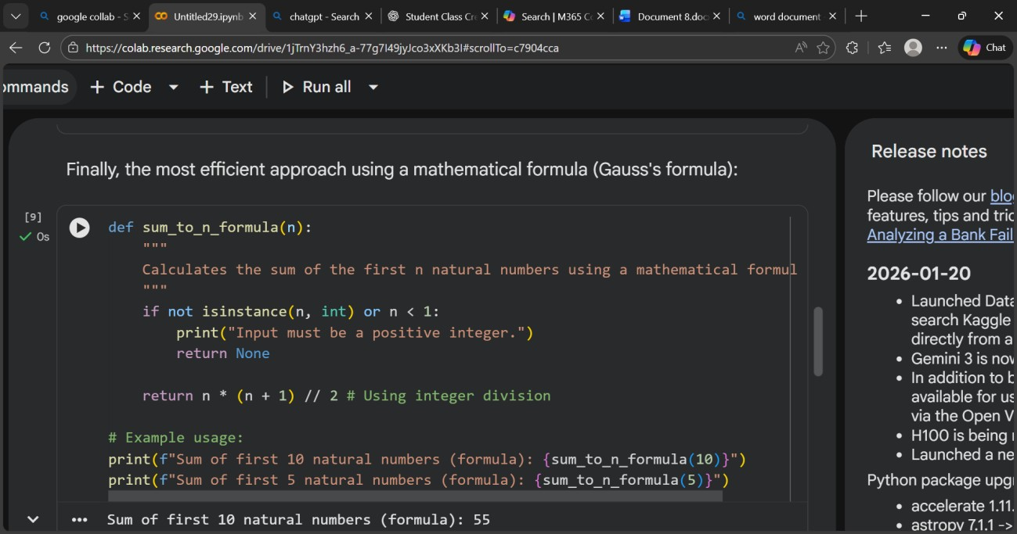
Output:
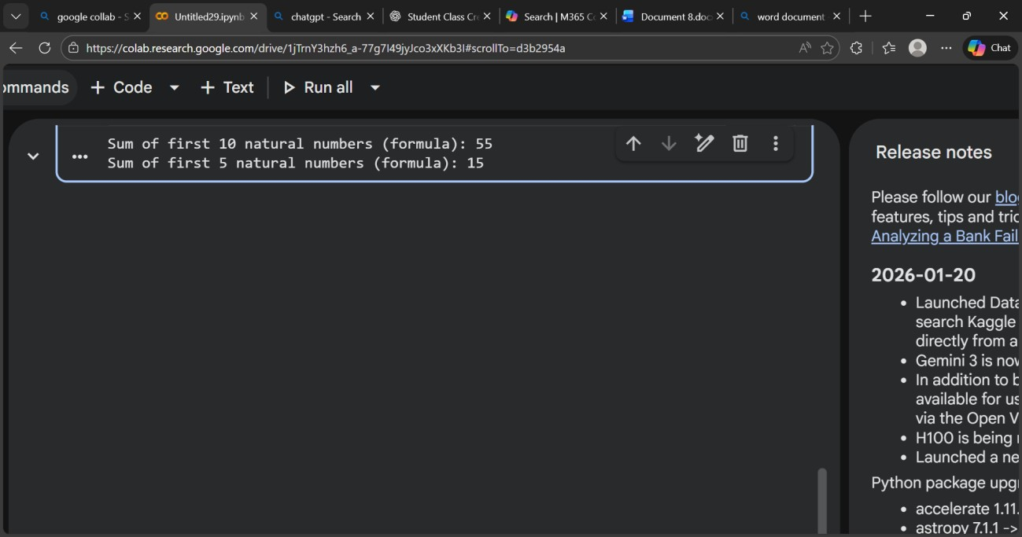
Explanation:
- In the for loop, the program repeats from 1 to n and keeps adding numbers to total.
- In the while loop, the same addition happens but the loop runs based on a condition (i <= n).

Task 5: Classes (Bank Account Class)
Prompt: Write a Python program to create a BankAccount class.
Requirements:
- Attributes: account_holder, balance
- Methods: deposit(amount) – add money withdraw(amount) – deduct money if sufficient balance check_balance() – display current balance
- Include comments in the code.
- Create an object and demonstrate deposit and withdrawal.
- Keep it simple and beginner-friendly.
Input:
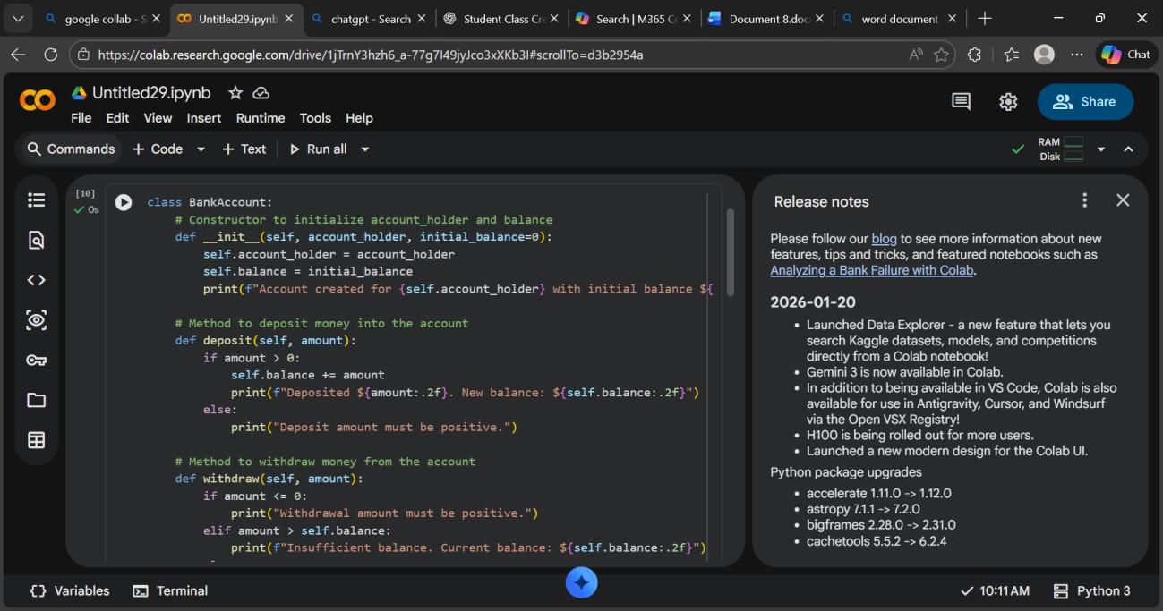
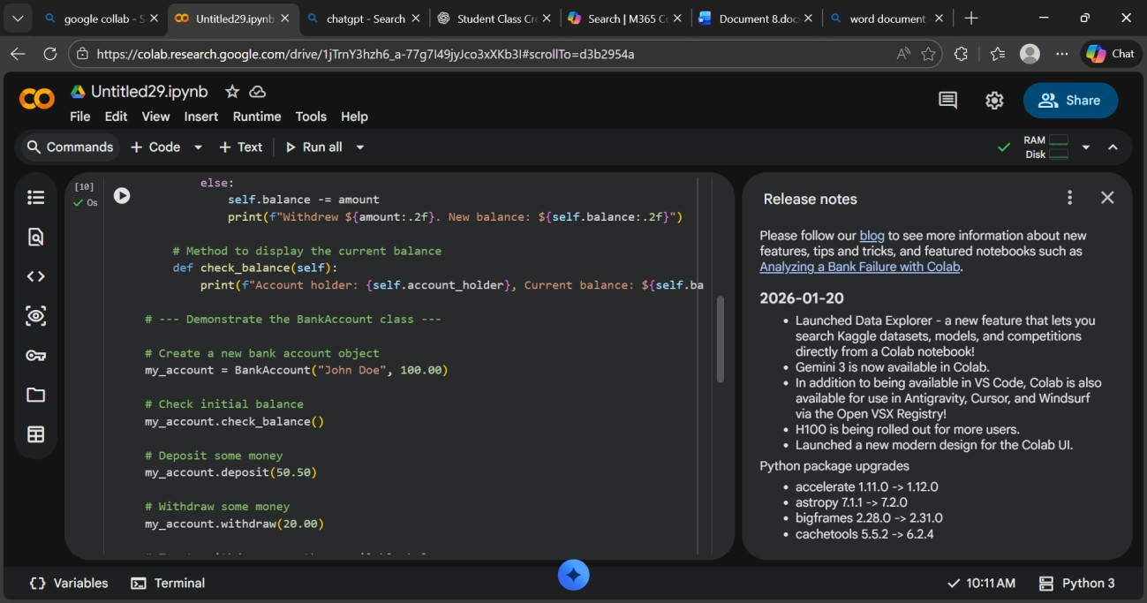
Output:
• 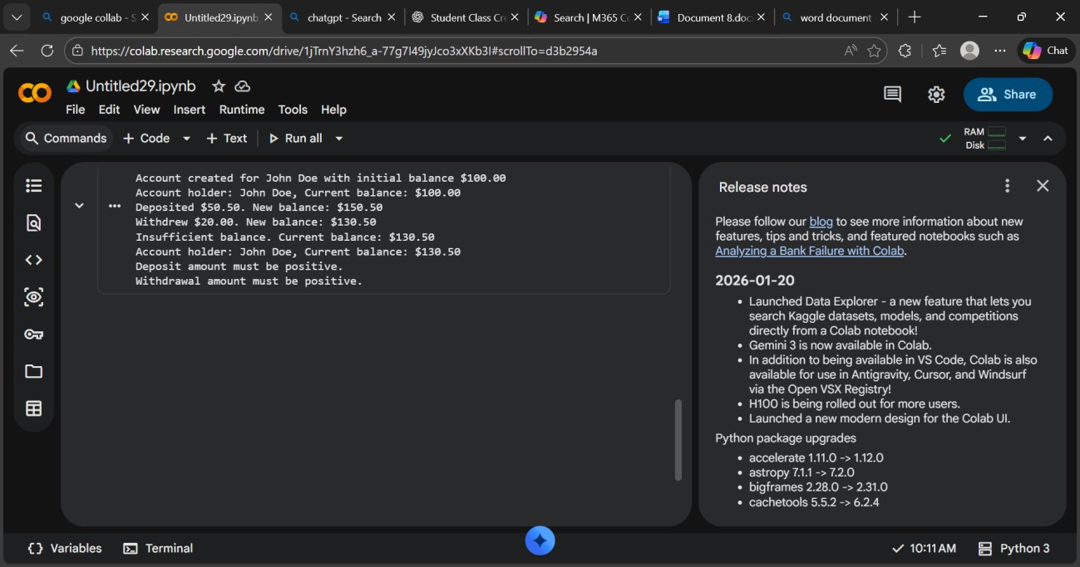
Explanation:
  - The class represents a bank account.
  - The constructor (__init__) sets account holder name and initial balance.
  - deposit() increases balance.
  - withdraw() checks balance before deducting (prevents overdraft).
  - check_balance() shows account details.

